**Mr. Visca’s: Calculus (sec 6.1)**

**Chpt 6 – Day 1: Slope Fields, Integrals**

***First, a little review!***

Consider: y = x2 + 3 y = x2 - 5

Then: y’ = y’ =

*So, does it really matter what our constant was in the original equations?*

**However, let's try to reverse the operation...**

Given y’ = 2x, find y We don’t know what the constant was, (3, -5 or whatever) so we put ________ in the answer to remind us that there might have been a constant.

***Hmmmm, maybe if we have some more information, we could find C.***

Given: y' = 2x, and y = 4 when x = 1, find the equation for y. This is called an ________________________

We need the initial values to find the constant.

An equation containing a derivative is

called a ____________________. It becomes

an initial value problem when you are given

the _________________ and asked to find the

original equation.

***SLOPE FIELDS***

Initial value problems and differential equations can be _________________ with a slope field.

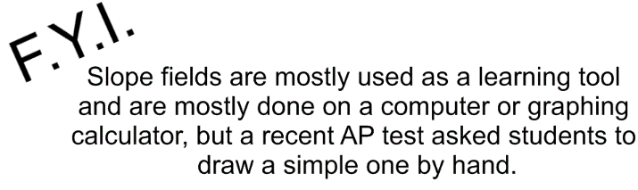

Let's use our y' = 2x example...shall we?

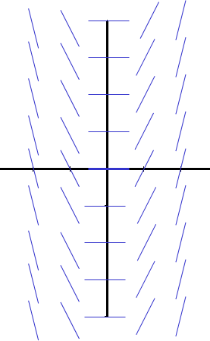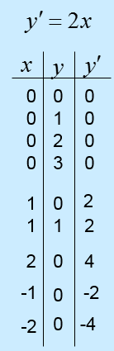

If you know an initial condition,

such as ( ________ ), you can sketch the curve.

By following the slope field,

you get a rough picture of

what the curve looks like.

In this case, it’s a ___________.

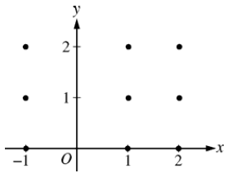What if you have to draw a slope field for: dy/dx = 3x + y

**Integral Types:** To “C” or not to “C”

y = x2

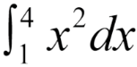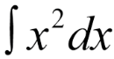Indefinite vs Definite

HW: section 6.1

#s:1 - 19 odd, 29-39 odd